Memorandum
To: [Name]
From: Dave Simon
Date: September 8, 2023
Re: Dairy and the Five Precepts

[Name], thanks for agreeing to read these thoughts on dairy and the five precepts. I’ve had these issues on my mind since May, when I attended a 10-day Vipassana retreat at Dhamma Manda. I was aware (and glad) that we would be asked to follow the five precepts. And when I saw a humane bug catcher in the hallway of my residence building, I was impressed at the level of compassion that would spur people to make and distribute such devices throughout the center. However, based on what I know of dairy farming practices, when I saw dairy served at meals, that seemed a bit inconsistent with the precepts, the bug-catcher, and other themes of compassion I encountered during the retreat.

The main premise of this memo is that times have changed, and dairy production methods that 50 or 60 years ago seemed humane have evolved into practices that routinely cause pain or death to mother and calf. These changes in production methods urge a fresh look at the idea that diary production is humane and consistent with the five precepts. In fact, it seems clear that modern dairy production methods, and the narrative surrounding these methods, violate at least three of the precepts (killing, stealing and lying) and arguably also violate the other two (sexual misconduct and intoxicants).

- The first precept – to abstain from killing (sometimes also expressed as a prohibition against causing harm). Dairy farming violates this precept in several ways:

  - Dairy cows have a natural lifespan of 20 years. However, they are typically slaughtered at the age of four or five when they cease to be productive.

  - Male calves born into the dairy industry have little value and no place in dairy production and are typically discarded or slaughtered for veal within 20 weeks of birth. They’ll spend their short life alone, without a mother, often in a “veal crate” like this:

  - Dairy cows are typically subjected to various forms of painful mutilation, such as branding, tail docking, and dehorning. All of these are painful. Studies find dehorning, for example, causes “acute and prolonged pain.” A few dehorned cows:

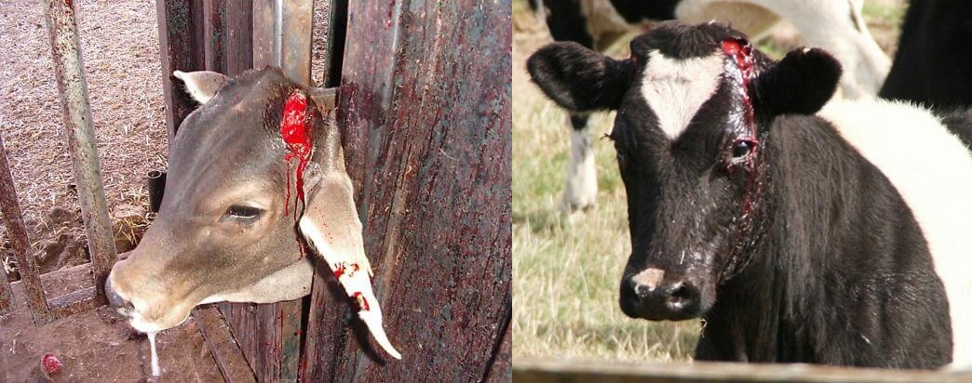

  - Most U.S. dairy cows will spend their entire lives indoors, hyper-confined to tiny concrete stalls like those below. Yet not surprisingly, research shows that cows, like people, don’t like being confined inside and prefer to be outdoors.

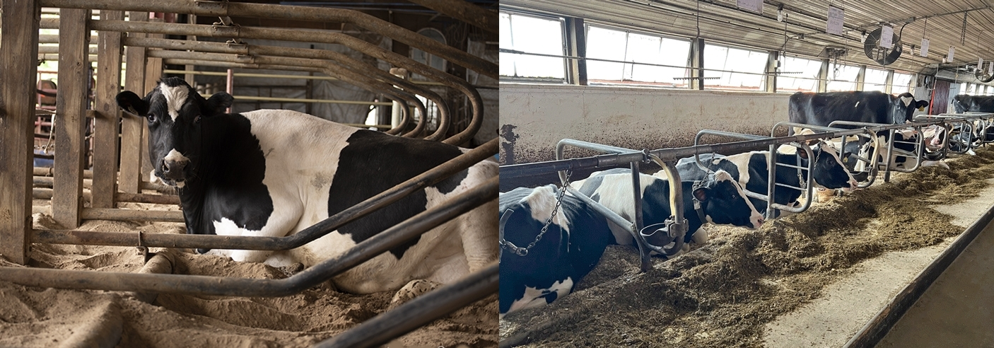

- The second precept – to abstain from stealing. Dairy violates this precept in two ways.

  - First, calves are literally stolen from their mothers. Because mammals (i.e., animals with mammary glands) form strong bonds around the practice of nursing their young, separating lactating cows from their calves is emotionally quite painful for the mothers and their calves. This short video illustrates some of these effects.

  - Second, a cow’s milk, which is intended for her calf, is taken from her – and the calf is fed formula instead. To deter calves from trying to breast feed, they are often fitted with “weaning rings” like these that make it painful and physically impractical to nurse:

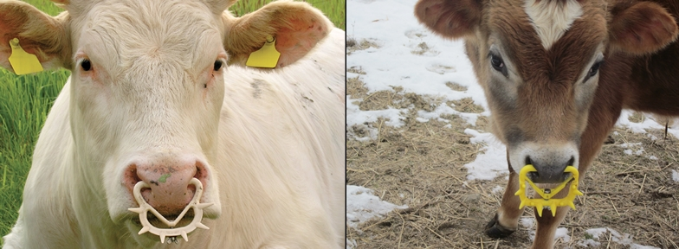
- The third precept – to abstain from sexual misconduct. Because dairy cows only produce milk when they’re lactating, they must be kept in a perpetual state of pregnancy. This requires that they be regularly artificially inseminated. The dairy industry itself coined the term “rape rack” to describe a device used to restrain a cow being inseminated. Research into cows’ cortisol levels has shown that, not surprisingly, artificial insemination cause stress to the animals. Thus, “raping” a cow to make milk is arguably an act of sexual misconduct that violates the third precept. A few examples of these restraint devices in use:

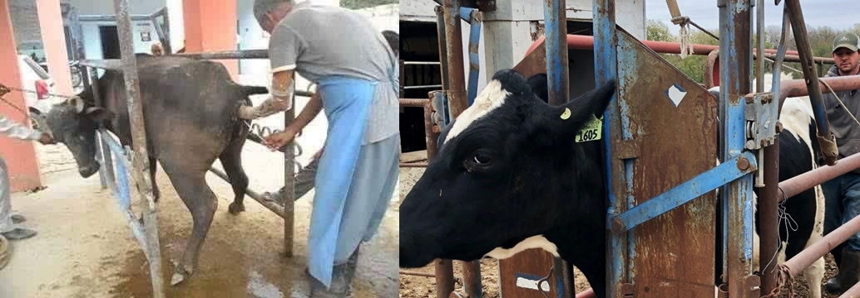

- The fourth precept – to abstain from lying. When the dairy industry tells us cows are treated humanely, as it does regularly, the overwhelming, contradictory evidence shows they are lying. And of course, if we tell one another that dairy is humane and consistent with the five precepts, we are arguably engaged in a lie as well – which also violates the fourth precept.

- The fifth precept – to abstain from intoxicants. Cow’s milk contains small quantities of opiates, which researchers believe may be to encourage calves to keep coming back to nurse until they’re old enough to wean. These intoxicants can make dairy products – especially cheese, which contains especially high concentrations of opiates – mildly addictive to humans. Again, this intoxicating effect of dairy arguably violates the fifth precept.

- Objections – for those accustomed to consuming dairy, as I was for decades, this information can be overwhelming. One may be tempted to raise any of these objections:

  - “Most dairy farms aren’t like that.” In fact, the Sentience Institute estimates that more than 70% of all dairy cows in the U.S. are raised in factory farms. The small family farm that once dominated the landscape has become the exception rather than the rule. Practically speaking, that means that whenever we consume any commercially available dairy product – milk, cheese, yogurt, butter or ice cream – the chances exceed 70% that we’re consuming the product of the miserable, harmful conditions described above. (By the way, conditions at smaller farms are not particularly humane either. Even at smaller farms, cows are slaughtered when they are no longer productive, mother and calf are separated at birth, and depending on the farm, some or all of the mutilations described above may be performed.)

  - “These photos and stories aren’t believable. Farmers wouldn’t treat their animals that way.” I’ve omitted citations to sources in this memo for brevity and simplicity. However, every assertion above can be easily verified by simply googling it. Alternatively, I’d be happy to provide a version of this memo that incudes citations.

  - “It’s too hard to ask people to give up dairy. People are used to their dairy products.” In fact, dozens of alternative, plant-based products are now available in virtually any supermarket in the U.S. These include many flavors of vegan cheese, milk, and ice cream; vegan butter, sour cream, cream cheese, and yogurt; and various other forms of vegan non-dairy products. Most of these are indistinguishable from the dairy-based versions. Frankly, it has never been easier to give up dairy.

- Conclusion. Decades ago, consuming dairy might have been consistent with the five precepts. But today, with the rise of factory farming, the evidence is overwhelming that dairy production and consumption violate all or most of the five precepts. Given the center’s aim of adhering to the precepts, and its practice of encouraging meditators to do so as well, I'd like to suggest switching to non-dairy alternatives during meals.

Thank you for taking the time to read this. I look forward to your thoughts.

D.R.S.

